I can only assume all classes that attended Easton Hospital School of Nursing had at least a one-year probationary period and then were awarded their caps. (Except for those early years when they probably only did rudimentary care and mostly housekeeping duties.)  
  
In 1969, with the first men in the 1969 graduating class, they awarded caps AND BADGES. This was a first for the school.  
  
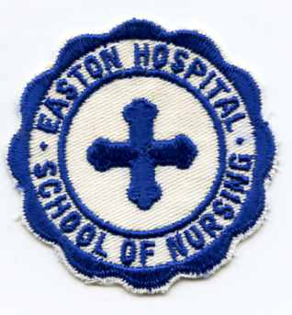  
Men's Badge ("cap")  
  
Does this bring back memories, anyone?  
  
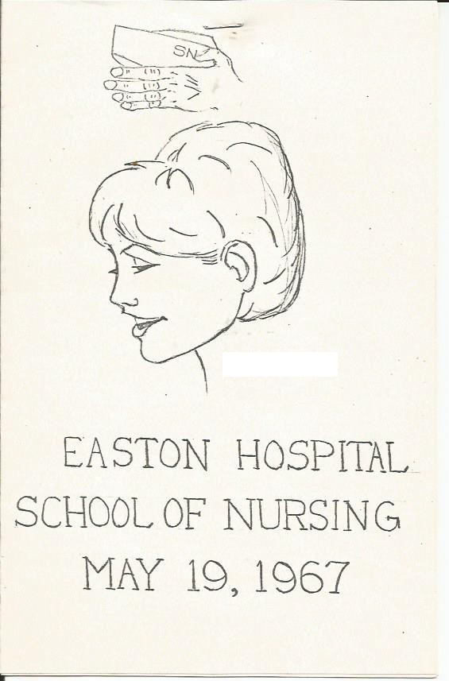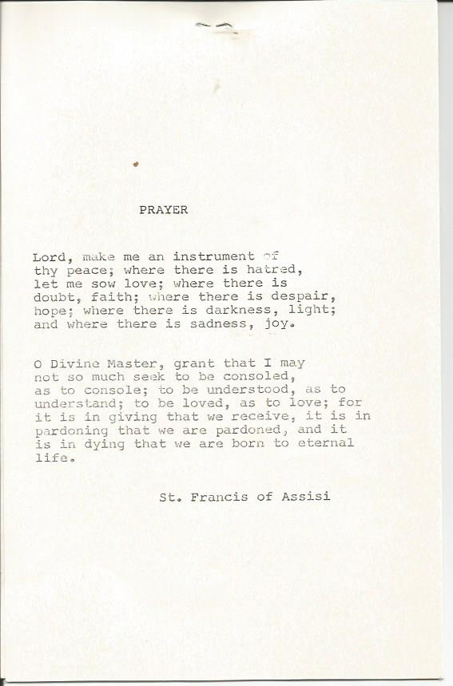  
  
  
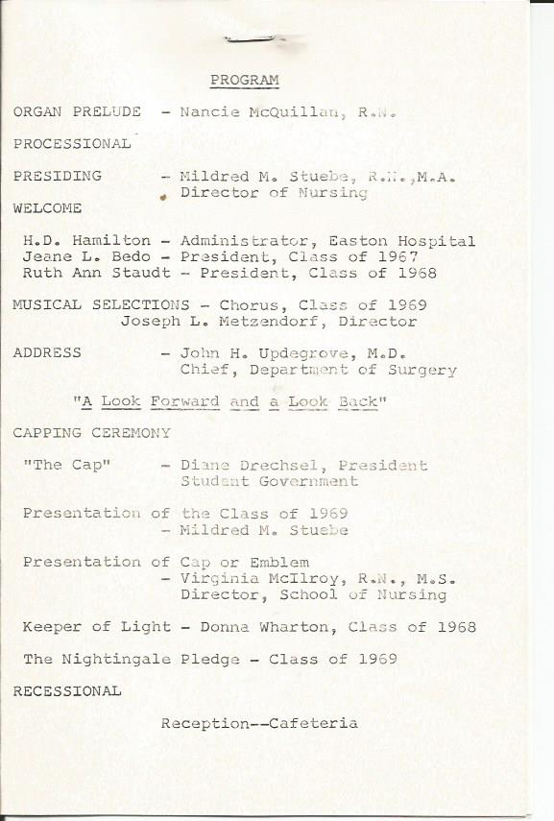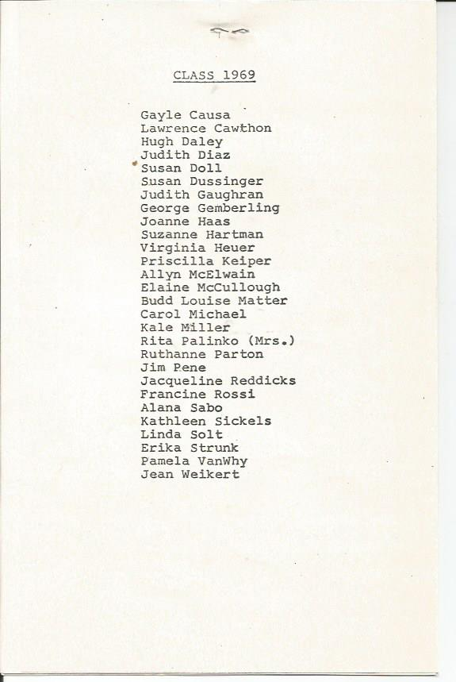  
  
George G. (USN-USAF RET)  
Easton Hospital School of Nursing  
Class of 1969

