**George Gemberling (USN-USAF RET)**

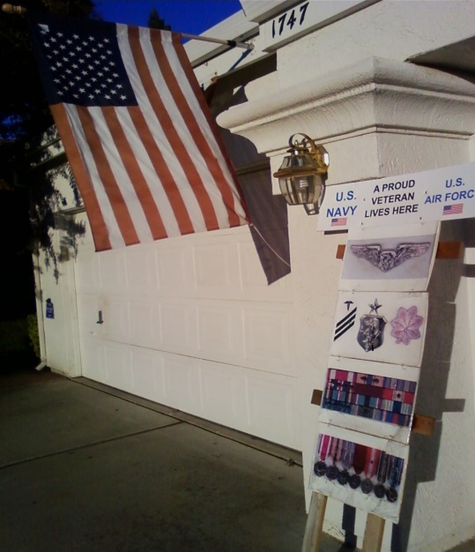

**Chief, Anesthesia Services**

**9th Strategic Hospital (Strategic Air Command) (1985-1991)  
Awarded "Outstanding Anesthesia Dept." - 1st in hospitals history   
(USAF's Hospital Services Management Inspection Team)  
Awarded Chief Nurse Badge  
Awarded Presidential Meritorious Service Medal  
Awarded 3 Air Force Commendation Medals  
Awarded Humanitarian Medal  
Awarded Air Force Achievement Medal  
Awarded Navy Good Conduct Medal  
Awarded 2 National Defense Medals  
Awarded Armed Forces Expeditionary Medal (Cuba)  
Awarded 9 Outstanding Unit Awards  
Nurse Anesthetist, RN, BS (Chapman University)  
USAF Anesthesia Residency Graduate, 2 year diploma Wilford Hall, Lackland AFB, TX,   
Voted President, Student Gov't.  
Air Command & Staff College Graduate, Air University, Maxwell AFB, AL  
Flight Nurse School Graduate, Brooks Aerospace Medicine, Brooks AFB, TX  
Awarded rare Leadership Award  
Brooks Aerospace Medicine Hyperbaric Chamber Medicine Graduate, Brooks AFB, TX  
Operating Room Nurse, (Circ. & Scrub, 1st Assistant) KI Sawyer AFB, MI & Lackland AFB, TX  
Officers Orientation School Graduate, Sheppard AFB, TX,   
Selected Flight & Squadron Leader of Class  
Easton Hospital School of Nursing Graduate. 3-year diploma, Easton, PA   
1st Male Student in 72 year Hospitals History  
Hospital Corpsman Striker, E-3 Stationed aboard following two ships:  
USS Independence CVA-62 - Forrestal-class Aircraft Carrier (1960-61)  
USS Boxer LPH-4 - Ticonderoga class Aircraft Carrier U.S. Marine Helicopter Assault (1961-62)  
Airman E-1, E-2 Willow Grove Naval Air Station, PA, USNR:   
Crewmember for Aircraft P2V Neptune, (Twin reciprocal engines)  
Antisubmarine Warfare - Sorties flown: North Atlantic Ocean; Maintenance, refueling, sonar buoys - (1957-60)**